| **Date** | **21/06/2025** |
| --- | --- |
| **Team ID** | **LTVIP2025TMID48146** |
| **Project Name** | **iRevolution: A Data-driven Exploration of Apple's iPhone Impact in India using Tableau** |
| **Maximum Marks** | **4 Marks** |

**Brainstorm & Idea Prioritization Template:**

Objective of Brainstorming:

To collaboratively generate and prioritize ideas for the dashboard design, data analysis, and storytelling flow. This helps identify what features will add the most impact and are feasible within our timeline.

**Step-1: Team Gathering, Collaboration and Select the Problem Statement**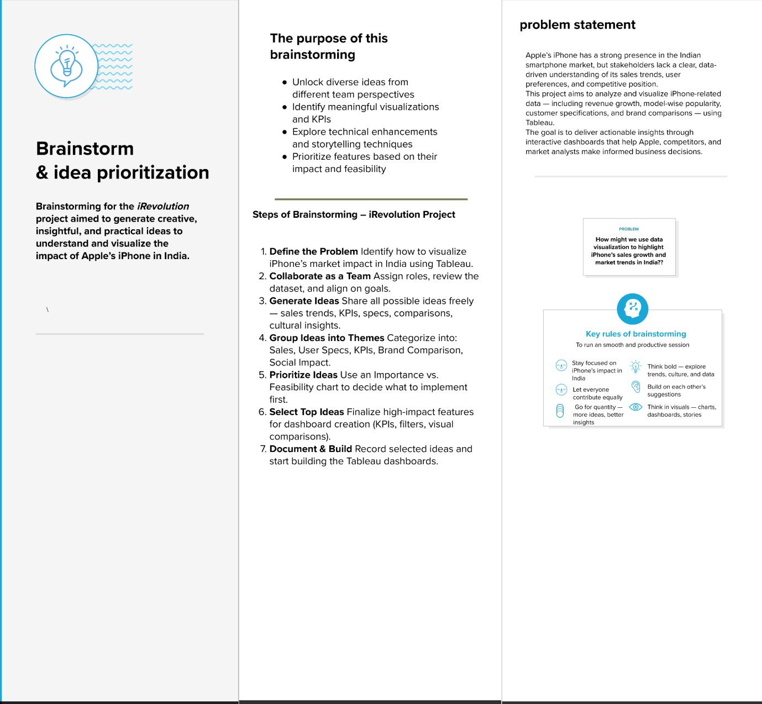

**Step-2: Brainstorm, Idea Listing and Grouping:**

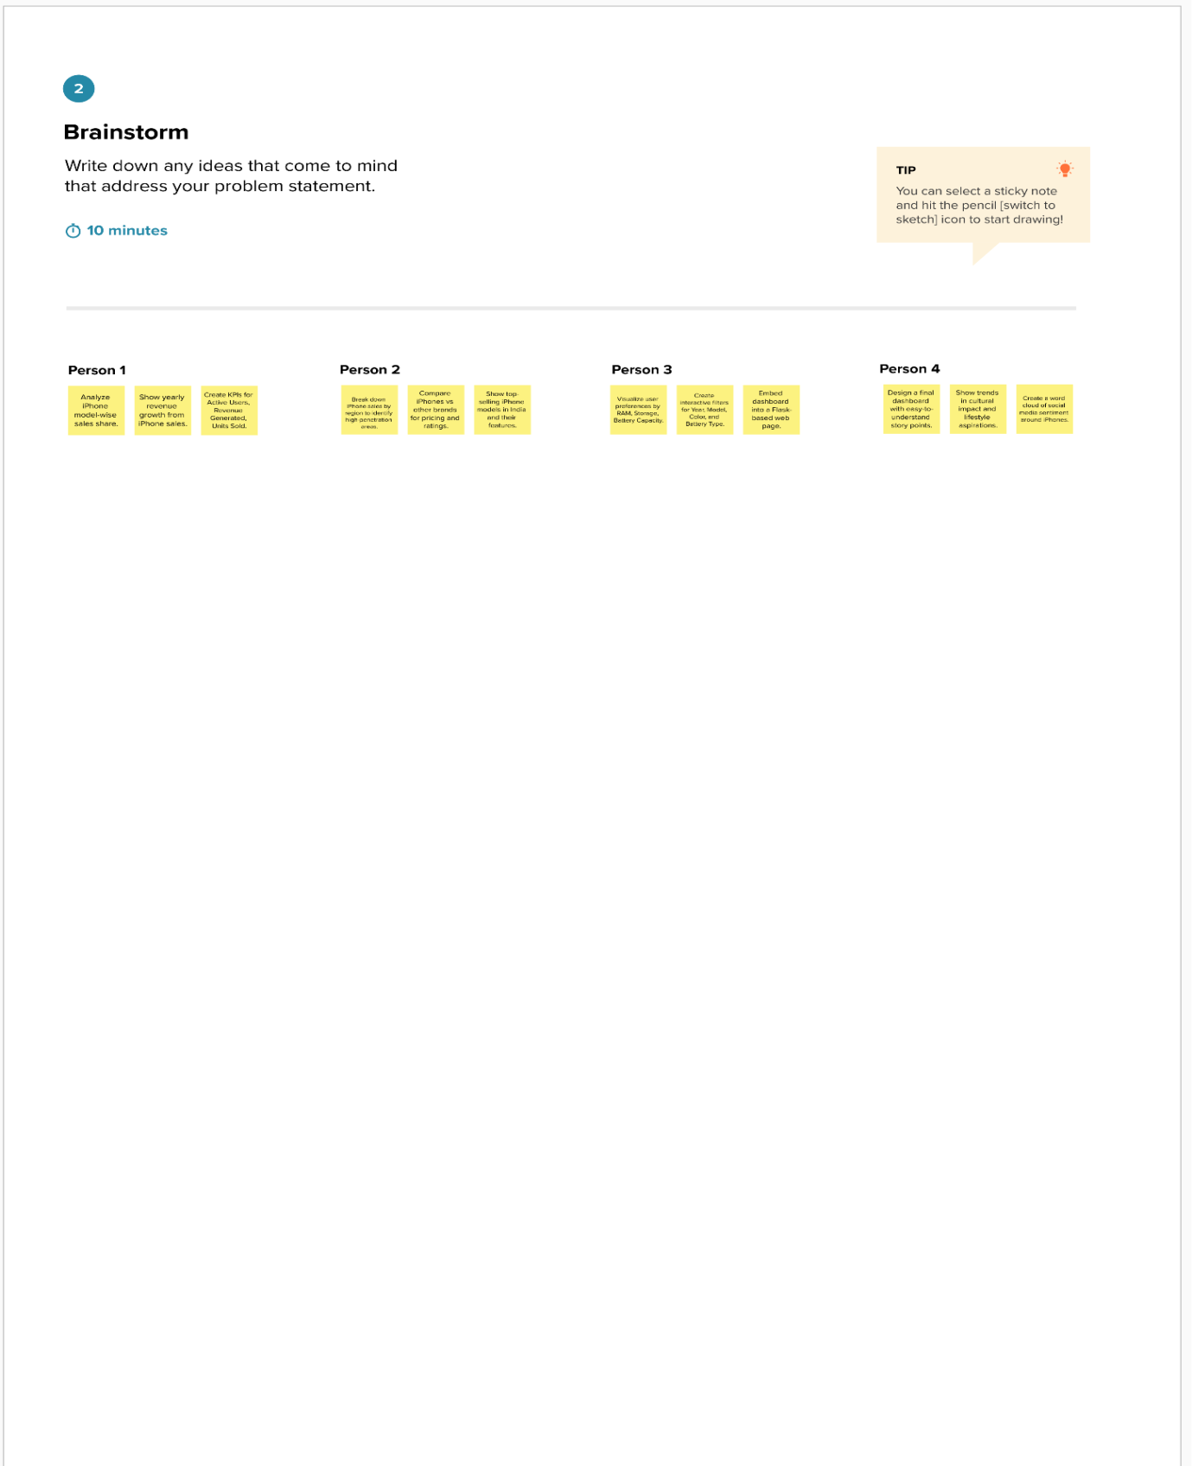

**Step-3: Idea Prioritization**

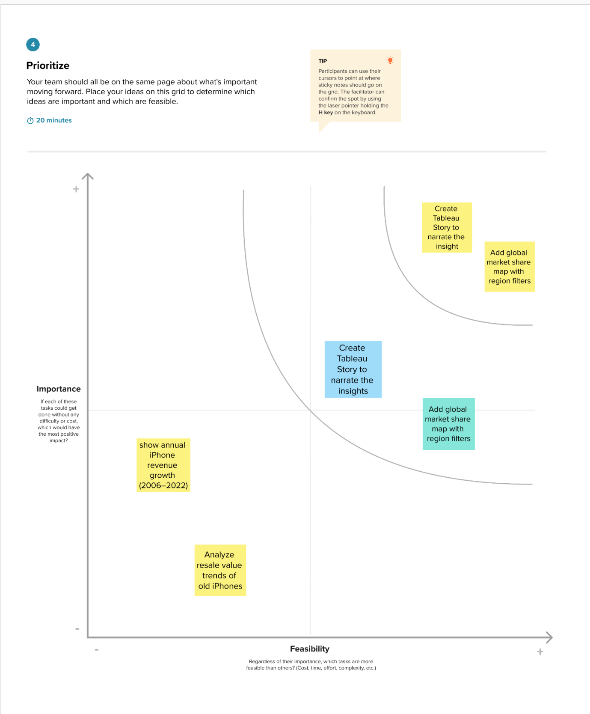

## 

## 

## 

## **Outcomes of Brainstorming – *iRevolution Project***

* Identified key KPIs: Active Users, Revenue, Units Sold
* Finalized core visualizations: Sales Trends, Brand Share, Model Specs
* Prioritized ideas based on impact and feasibility
* Selected top features for the dashboard (filters, story points, global view)
* Grouped ideas into themes: Sales, User Preferences, Cultural Impact
* Gained a shared understanding of project direction and goals
* Aligned on actionable next steps for dashboard development